**Moderate to Severe Evaluation**

Sample_id : **TKAXHP(Dog)**

Link:<https://release.animalbiome.com/pet/assessment/report/summary/d9c341c8-940e-415a-ae03-c9d65477c378>

Cats and dogs:

Any two of the following:

(

High Red Flag Megamonas OR (failed)

High Red Flag Sutterella OR (failed)

High Red Flag Collinsella OR (failed)

Low Red Flag Bacteroides OR (**passed**)

Low Red Flag Blautia (**passed**)

);

OR

Dogs:

8 or more yellow flags (failed)

OR 8 or more red flags **(passed**)

High red megamonas,suttrella and collinsella failed.

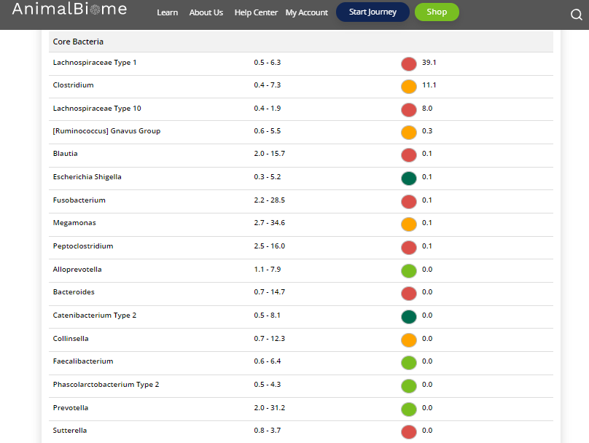

Low group evaluation:

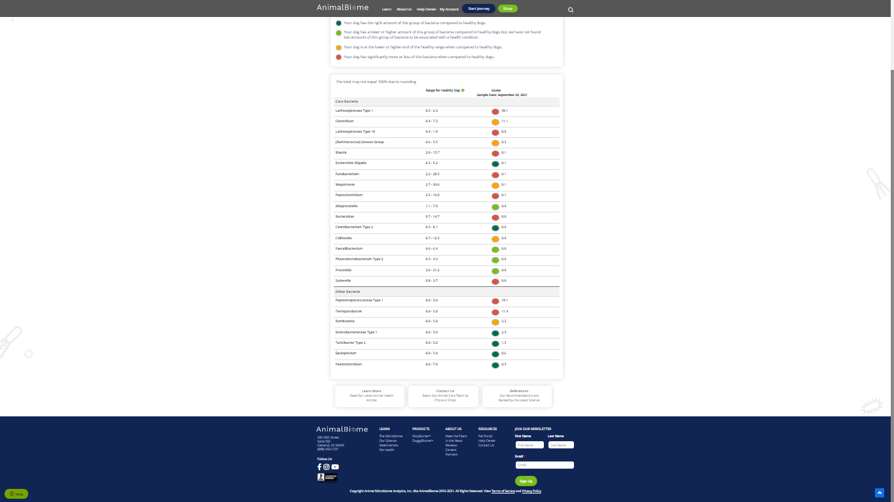

low red blautia : **passed**.

Low red bacteroides : **passed** (two conditions satisfied ) in the primary group.

Total yellow flags : 5

Red flags : 9

The result : **True False True**

Moderate to severe results:Pass

Expected result : Moderate to severe

Achieved result : passed.

